Focus Pocus Installation instruction
(For Mac)

1.Pair MindWave Mobile headset
2.Install Focus Pocus and FocusIn
3.Start Focus Pocus training
4.Check training report

1. Pair MindWave Mobile headset

1-1.Start. Please prepare one AAA battery and read below picture for headset switch mode.
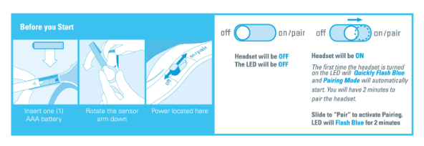

1-2.Switch headset to pairing mode
Turn on the headset. Pairing mode should start automatically with the LED quickly flashing blue(2/sec).If it does not, hold the power switch in the "ON" position for 3 seconds until it flashes. It is now in pairing mode.
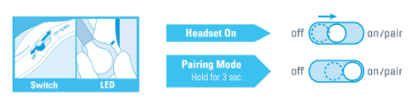

1-3.Pair headset
- Click “System Preferences” in the bottom right-hand corner of screen, select “Bluetooth”, click “+” to search headset
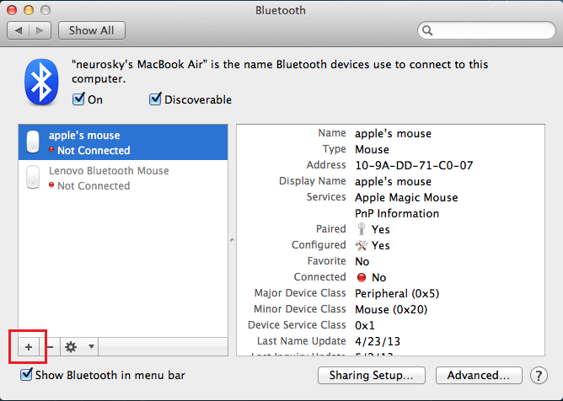
- Select “MindWave”, click “Continue”, then click “Quit”. You will see MindWave Mobile in device list
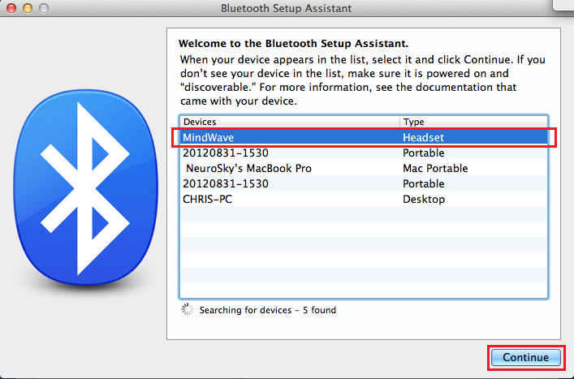
- Select “MindWave Mobile” and click “Edit Serial Ports…”
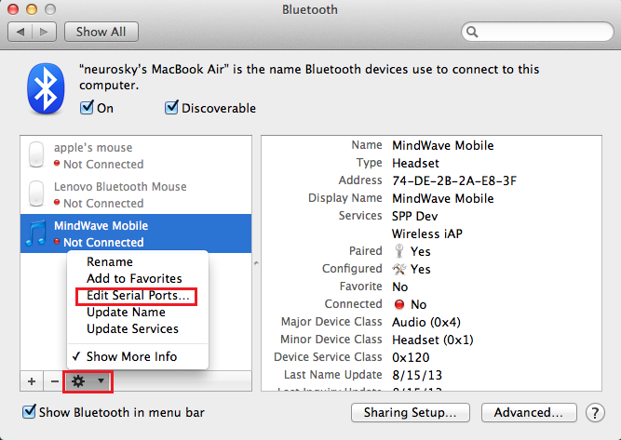
- Click “Apply” to finish pairing headset. The MindWave Mobile headset will show connected status.
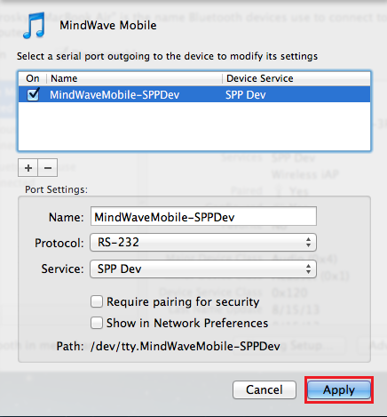

2.Install Focus Pocus and FocusIn
After finish pairing headset, please start install Focus Pocus

2-1. Install Focus Pocus
2-1-1. Insert Focus Pocus CD, and double click to open CD directory
2-1-2. Open “Mac” folder and double click “Focus Pocus-Setup.app” to start installation
2-1-3. Select installation directory and parameter, click “Continue” to start installation. If you want Focus Pocus auto-launch after installation, please check “Start application after installation”. Also, you can use the install directory in “Installation location”
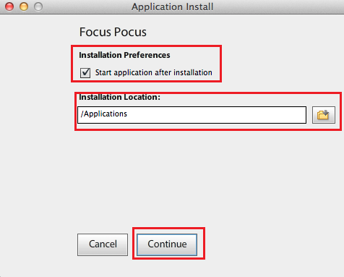
2-1-4.If it promote Adobe Air message during, please click “I Agree”. If system popup password required window, enter your system password then click ok
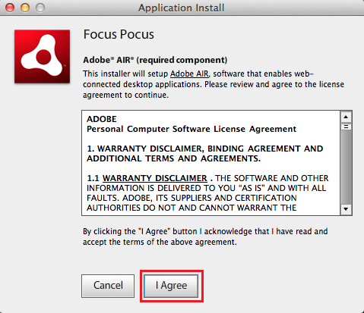
2-1-5. After finish installation, Focus Pocus will be auto-launched. If it did not auto-launched, please open Focus Pocus from Finder/Applications.

2-2. Install FocusIn
2-2-1. Open “Mac” folder and double click “FocusIn-Setup.app” to start FocusIn installation.
2-2-2. Select installation directory and parameter, click “Continue” to start installation. If you want auto-launch FocusIn after installation, please check “Start application after installation”. Also, you can use the install directory in “Installation location”

3.Start Focus Pocus Training
To start training, you need to online register account in Focus Pocus. The accounts include one parent account and several child accounts. (each child account need to be activated by license key)

3-1.Register Focus Pocus account
3-1-1.Register parent account
- Open Focus Pocus, then click “Register”
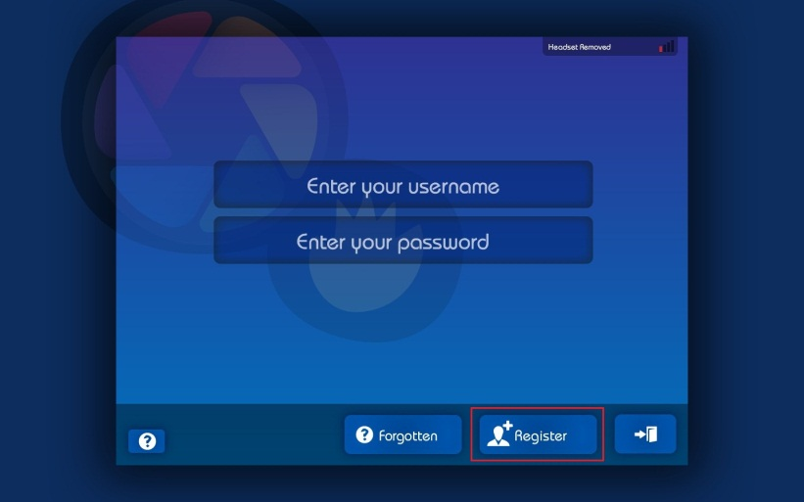
- Fill in your information, then click “Register”
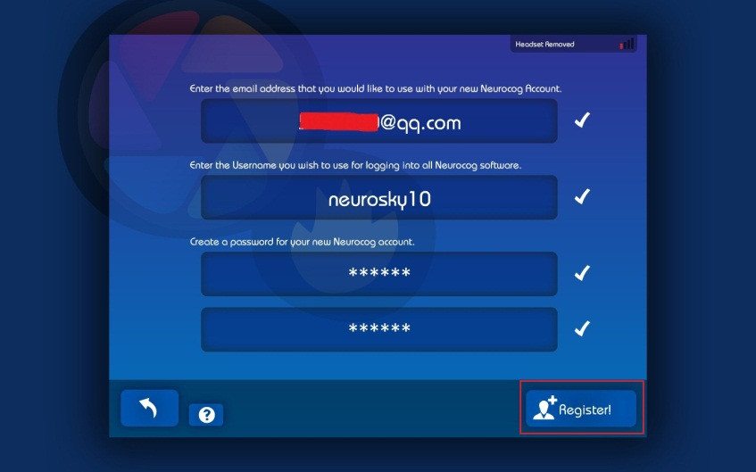
- Enter your parent account and click “” to login
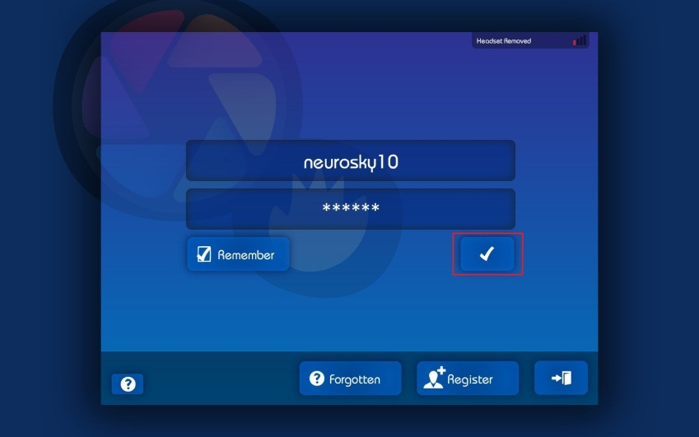
3-1-2.Register child account
- Click “Next”->“Close”->“Create account”
- Fill Child information, then fill in license key to activate the account.

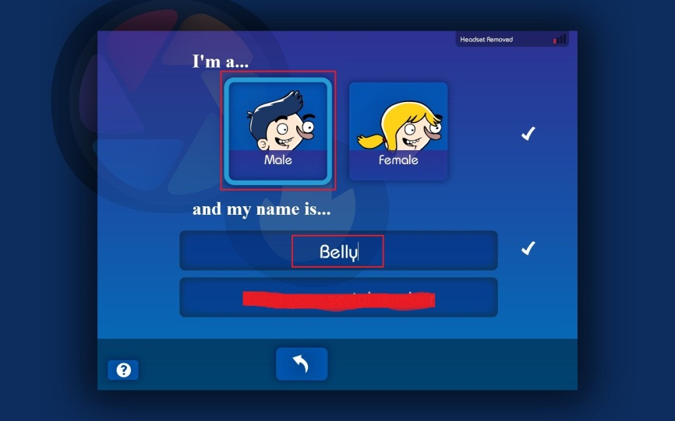
- Set password for Child account. Now enjoy Focus Pocus!

3-2.Start Focus Pocus training

3-2-1.Wear headset
Please wear your headset as below instructions,
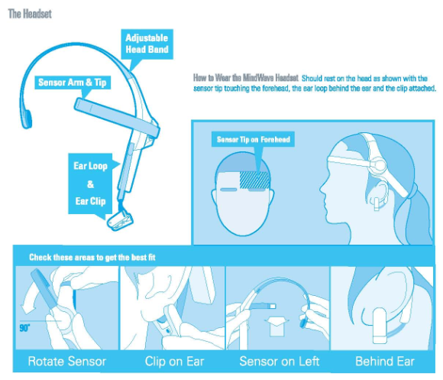

3-2-2. Start Focus Pocus Training
Open Focus Pocus, Login with parent account, then Child account. Then start your training sessions. To read each training instruction, please click “Show me”

3-3.Headset signal Help
During training, If you meet problems like below picture,
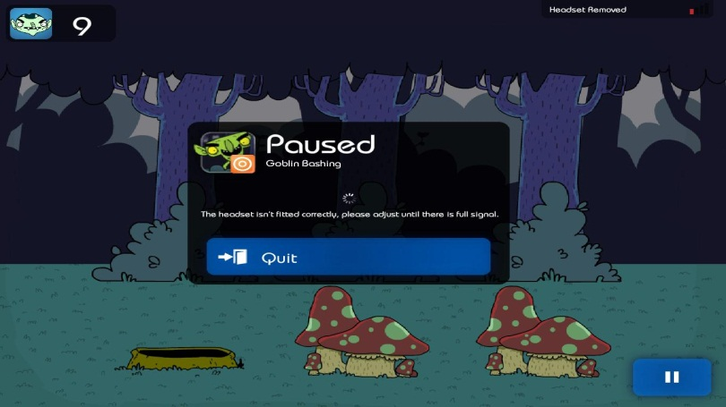
Please adjust your headset as below picture,
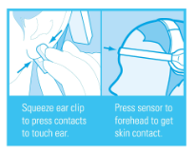

4.Check training report
Open FocusIn from Finder/Application. Then Login with parent account, then you can see the training report on the page.

